ACTIVITIES & CLUBS

Wood Dale Junior High
2018-2019

Club Membership

It is time for clubs at the Wood Dale Junior High School to begin! This is a great opportunity for students to get to know our teachers and other students outside of the classroom walls. Students may join a club later in the year if other commitments prevent them from attending at this time. There is a 4:00 p.m. activity bus provided for the students. The schedules for the late bus stops are available in the WDJH office. You must be eligible to participate in clubs.

*REMINDER: Students need to have paid the $25 activity fee in order to ride the 4:00 p.m. bus. Listen for the morning announcements about club meetings.

GET INVOLVED!!!

Builders Club

The Builders Club is a service organization that sponsors fundraisers and contests for our school and the community. Come be a part of the fun and lend a helping hand. Take the challenge to make our school a better place! Builders Club is hosted by Mr. Allaire and Mrs.Tiritilli-Hromada. There are monthly meetings, as announced; other meetings on an as needed basis throughout the year.

Do you need a quiet place to study and to work on your homework? Do you want to be more organized and learn the skills to become successful? Come to Homework Club and keep on top of your work!

*Meetings: Every Monday, Tuesday and Thursday.

Art Club includes drawing, crafts, watercolor and/or clay. Due to Art Club’s limited number of participants, each activity will have a sign-up sheet, having students participate on a first-come-first-serve basis. The Art Club is sponsored by Mr. Bruce.
The meetings are:
6th grade: Mondays in October and November
7th grade: Tuesdays in February and March
8th grade: Tuesdays in April and May

Theatre Tech Club
Are you interested in being a part of the musical without everyone looking at you? Then join Stage Crew. Be a part of the team behind the musical- help with make-up, run the spot lights, or move the furniture on stage. Most importantly, attend the Cast party after the show!

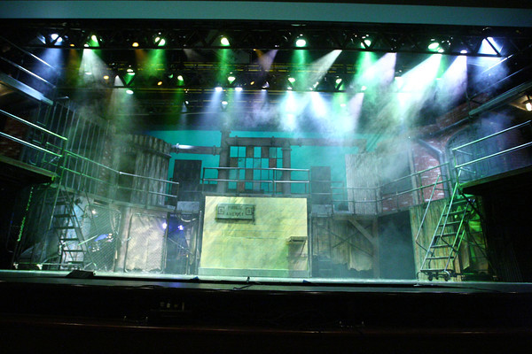

CHESS CLUB
Students will meet to play chess and develop strategies. A tournament will be organized for all participants. Beginners are welcome! The Chess Club is hosted by Mr. McCann. Meeting times will be determined.

Yearbook Club

Yearbook Club will be creating and designing the 2018-2019 yearbook. If you are interested in publishing, layout design and photography; this might be the perfect club for you. The sponsors are looking for a dedicated group of students that is willing to put in the time and effort to make this a memorable part of our history.
The Yearbook Club is sponsored by Mrs. Bjerga-Palm and Ms. Hasse.
*Meetings: as announced.

Girls on the Run (G.O.T.R.) is a life-changing, experiential learning program. The program combines training for a 3.1 mile running event with self-esteem enhancing, uplifting workouts. The goals of the program are to encourage positive emotional, social, mental, spiritual, and physical development. G.O.T.R. begins and the spring and meets every Tuesday and Thursday from 3-4:30. This club culminates in a 5K off campus run. G.O.T.R. is limited to 15 girls. Please see Mrs. Phillips and Mrs. Tiritilli-Hromada for more information.

Panther PAC
(Principal Advisory Committee)
New Club Coming Soon!
Students have the opportunity to represent their Advisory class and offer student voice in how to improve our school and what students want for our school community. One student from each Advisory class serves with the committee for one trimester. The student representative is responsible for gathering, reporting and communicating information to and from their Advisory class and committee meetings. The Panther PAC meets twice a month with Mrs. Skarzynski during the school day.

FUTURE CITY CLUB
Join Mr. West this fall as he guides our 8th graders to compete in the Future City Competition ( http://futurecity.org/ ) Students will be competing against others schools in the Chicago Region with the chance of moving on to the national competition held in Washington DC.
When: Over the next 4 months, student will form teams and work on a project as a group. Time will be given after school, however some work may have to be done on your own time.
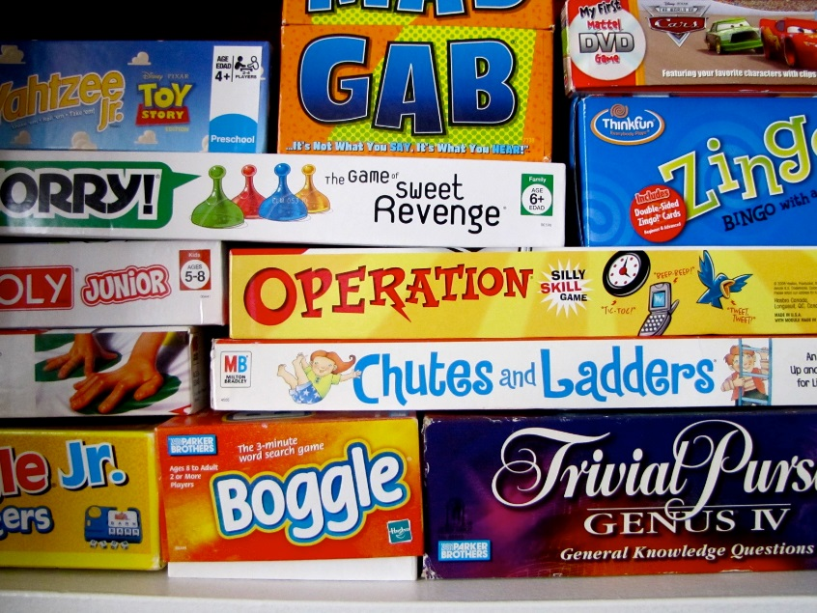
Board Games Club
If you haven't played board games except for being playing Monopoly and Risk with grandma on vacation you’re missing a lot! Board games are in the middle of a massive resurgence, with thousands of games and hundreds of styles, levels of difficulty, and more fun than even grandma’s house! If you haven't played a modern board game, you're really missing out on a world of fun. Come join us and find some new board games that are better than video games! See Ms. Siakel for more details! Club meets on Friday’s after school.

School Newspaper Club
Come be a part of our WDJH Panther Newspaper Club during the 2017-18 school year! Students must apply to be a part of this club. Open to all students interested! Students will conduct interviews, write and edit stories, take photos, and film and edit each trimester throughout the school year for the entire school community to enjoy. Please see Mrs. Ampulski for more details!
Sports try outs:
Clubs start at various times during the year. Please see each club for dates or contact the sponsor.
- Cross Country –NOW!
- Basketball (Girls) Early October
- Basketball (Boys) Early December
- Cheerleading –Early December
- Poms – Early December
- Volleyball (Boys) Early February
- Volleyball (Girls) Early Frebruary
- Track – Early April

